ASSIGNMENT-14

Lab 14: Web Design Application – AI-Assisted HTML/CSS/JS
TASK-1
AI-Assisted Portfolio Website Scenario:
A student wants to showcase their projects, skills, and contact details in a portfolio website. Instead of writing all code manually, they want to speed up the process using GitHub Copilot.
- Use Copilot to generate an HTML structure for a personal portfolio page (sections: Home, About, Projects, Contact).
- Ask Copilot to suggest responsive CSS styling for the layout (e.g., grid/flexbox).
- Customize Copilot’s suggestions to add a hover effect on project cards.
PROMPT:
"Generate Python code that automatically creates a personal portfolio website. The Python program should:
- Create an index.html file with sections: Home, About, Projects, and Contact.
- Create a style.css file with responsive design using Flexbox or Grid layout.
- Add a hover effect on project cards.
- Use clean, modern, and responsive HTML/CSS structure.
The code should save both files in the current directory and print a confirmation message when done."
CODE:
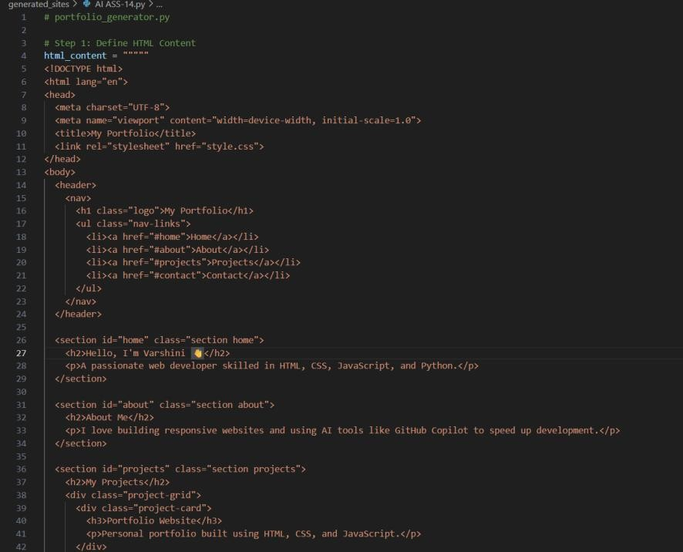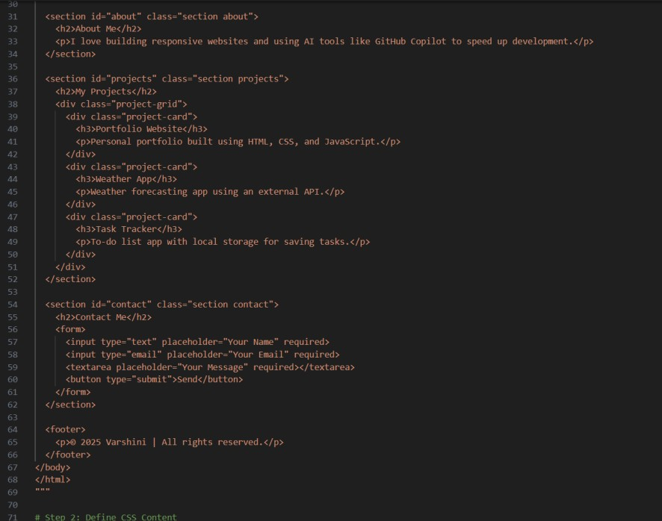

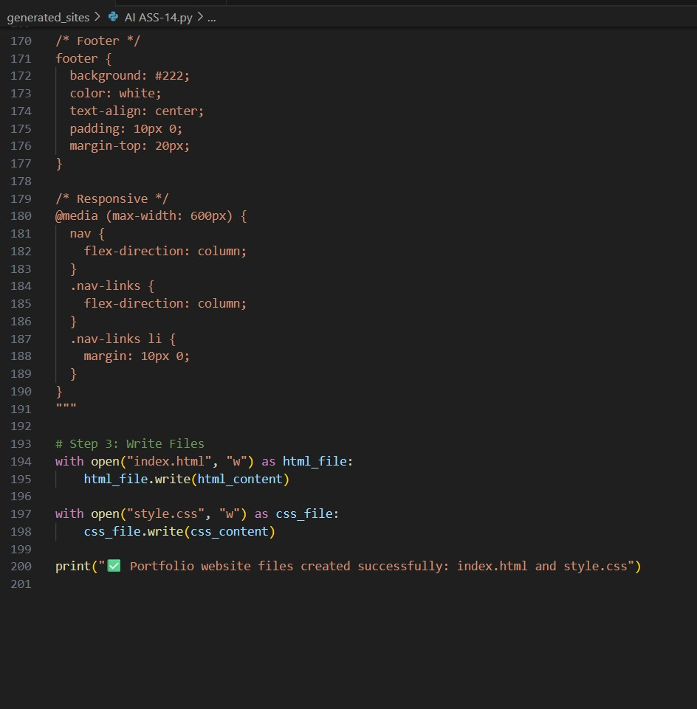
OUTPUT:

Files Used:
- index.html
- style.css
- script.js (optional)

TASK#2:
AI-Generated Restaurant Landing Page Scenario:
A local restaurant needs a simple landing page with a navigation bar, menu highlights, and an image gallery. The developer wants to quickly generate it using AI assistance.
- Use Copilot to create a navigation bar with links (Home, Menu, Gallery, Contact).
- Generate a menu section styled with CSS cards.
- Add a JavaScript-based image slider for the gallery, with Copilot suggesting the base code.
PROMPT
Generate a Python program that automatically creates a restaurant landing page.
The program should:
Create an index.html file with sections: Home, Menu, Gallery, and Contact.
Add a navigation bar with links to each section.
Design the menu section using responsive CSS cards for food items.
Add a JavaScript image slider for the gallery section that shows multiple food images with next/previous buttons.
Use clean, responsive HTML, CSS, and JavaScript code.
Save the generated files (index.html, style.css, script.js) in the current directory and print a success message after creation
CODE:
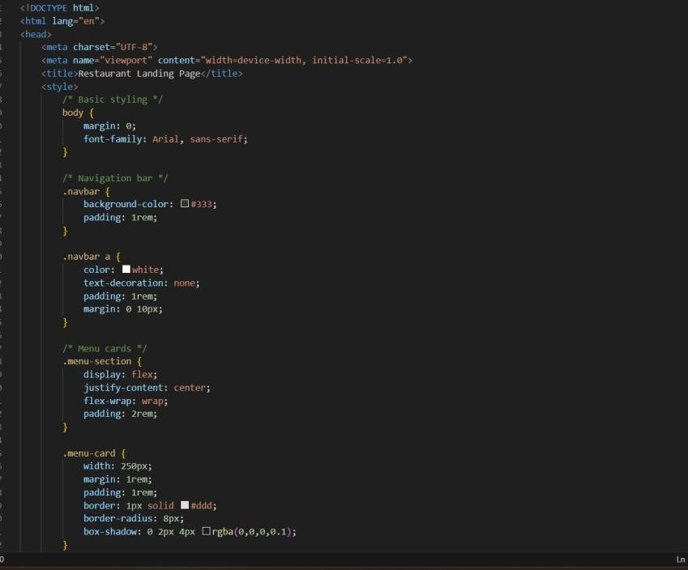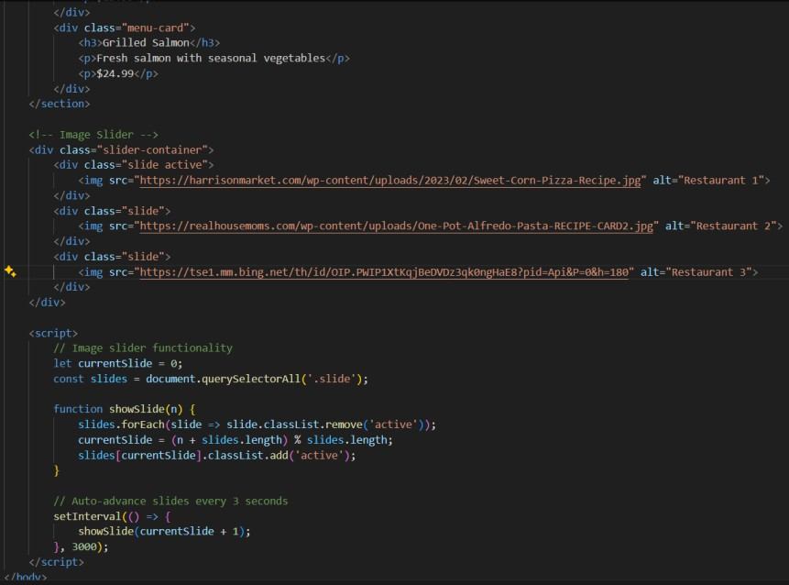

OUTPUT:
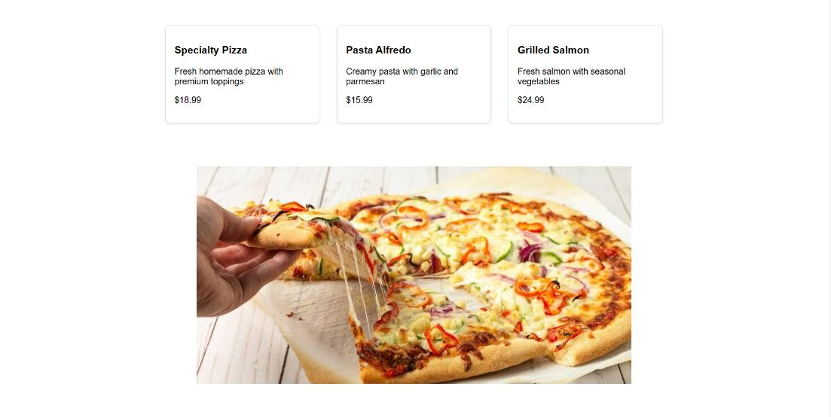
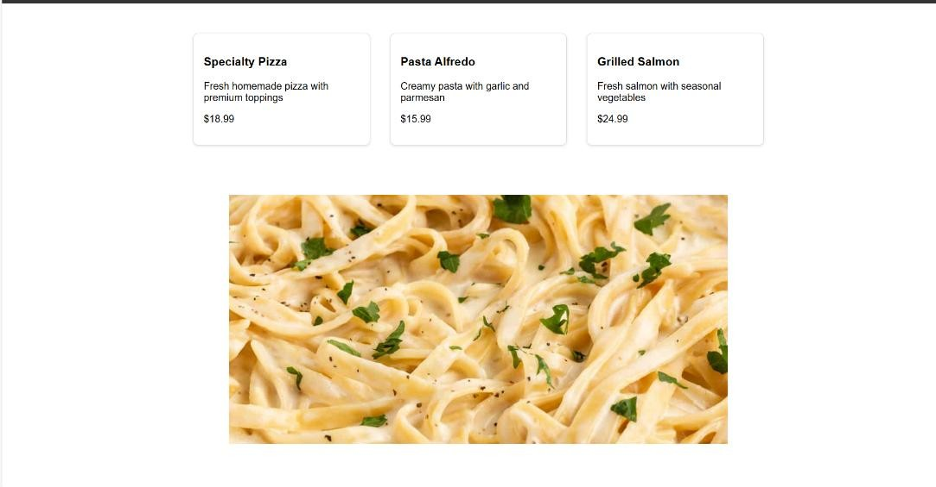
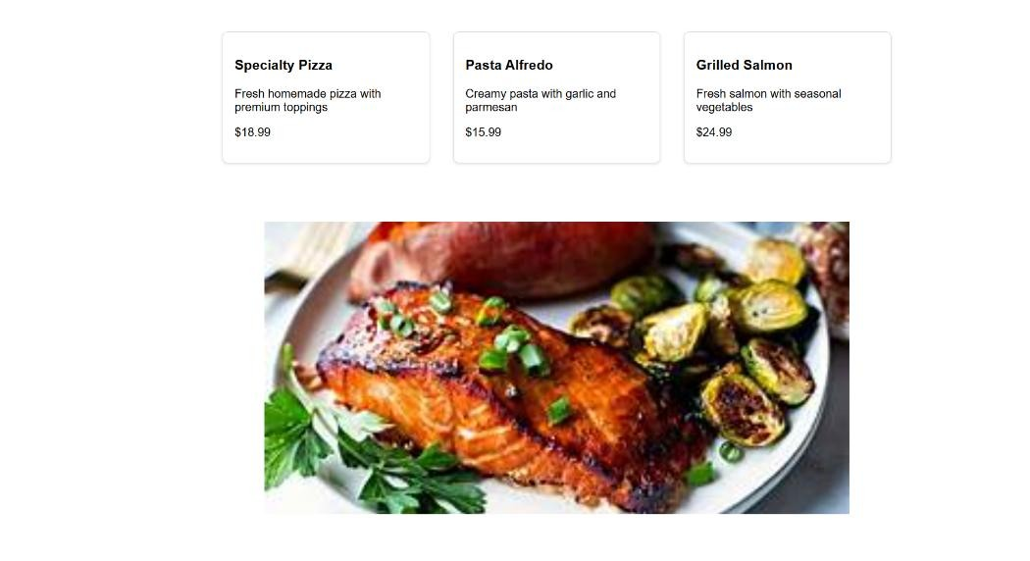

TASK-3:
AI-Powered Event Registration Form Scenario:
SR University is hosting a tech fest. They need a web-based registration form for students. The form must validate user input in real-time. • Ask Copilot to generate an HTML form (fields: Name, Email, Phone, Department, Event Selection).
- Use Copilot to assist in adding CSS styling for an attractive form layout.
- Implement JavaScript validation (e.g., email format check, phone number length check) using Copilot’s suggestions.
PROMPT:
- Create an index.html file with a registration form containing the following fields: Name, Email, Phone, Department, and Event Selection (dropdown).
- Create a style.css file with modern, responsive styling for the form (centered layout, input box styling, and hover/submit button effects).
- Create a script.js file with JavaScript-based real-time validation for:
  - Checking email format
  - Ensuring phone number has exactly 10 digits o Making sure all fields are filled before submission
- Display appropriate error messages near invalid fields.
- Save all three files (index.html, style.css, script.js) in the current directory and print a message like “Event Registration Form Created Successfully.”

CODE:
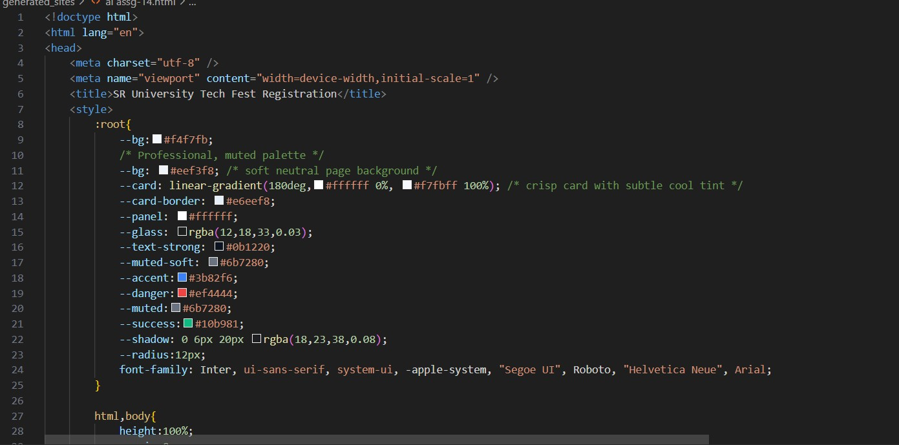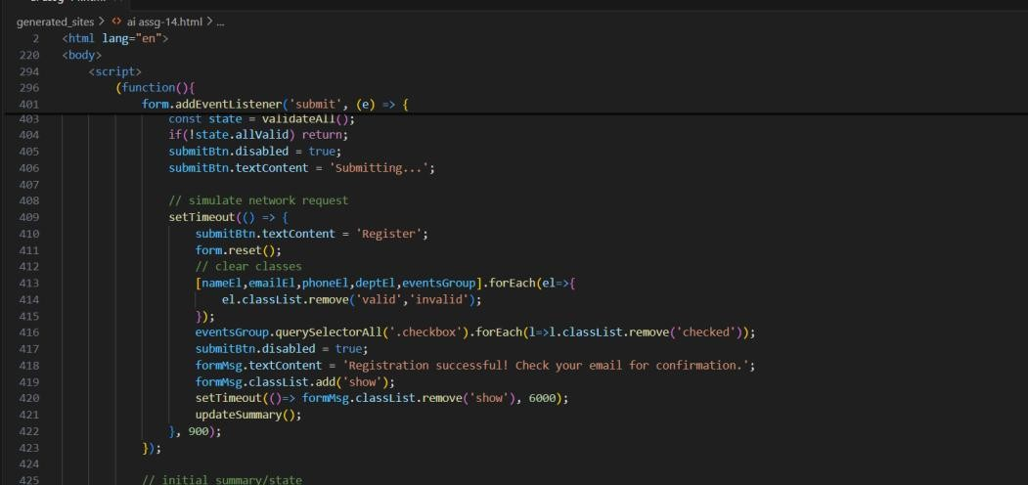

OUTPUT:


TASK4:

A startup wants a basic e-commerce product page to display products with prices and an “Add to Cart” button.
- Use Copilot to generate a grid-based product catalog in HTML/CSS.
- Implement a JavaScript “Add to Cart” functionality with Copilot’s guidance.
- Modify Copilot’s suggestions to include a cart counter at the top-right corner of the page.
PROMPT:
- A grid-based product catalog displaying multiple products with their names, images, prices, and “Add to Cart” buttons.
- A cart counter icon at the top-right corner that updates dynamically whenever a user clicks “Add to Cart.”
- Use responsive CSS (Flexbox or Grid) to make the layout look good on both desktop and mobile screens.
- Use JavaScript to implement “Add to Cart” functionality and update the cart counter in real time.
- Style the page with modern, attractive colors, rounded product cards, and hover effects on buttons.
- The project should include three files — index.html, style.css, and script.js.
CODE:
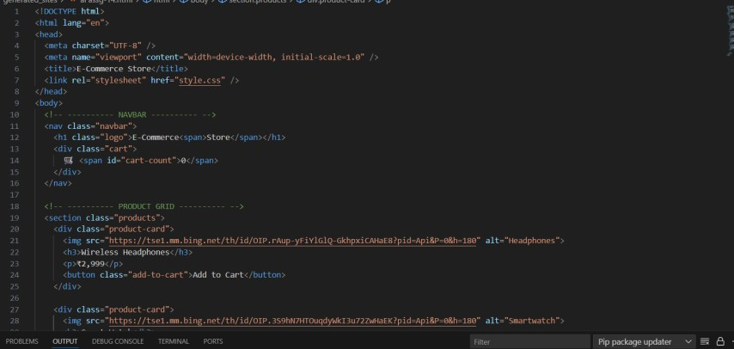
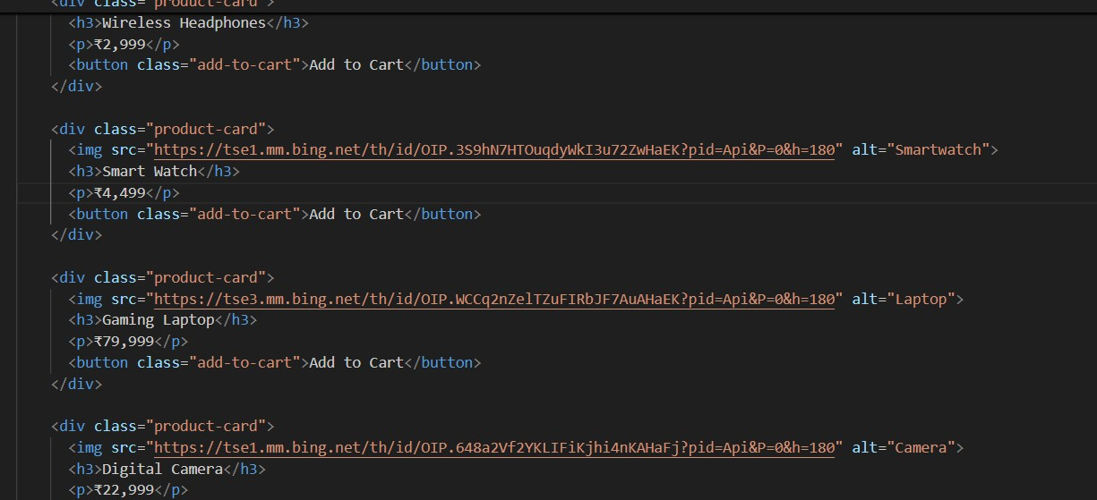
OUTPUT:
